Safeguarding - The Deborah Ubee Trust
Policy Statement
The Deborah Ubee Trust (DUT) recognises the right of every individual to be kept safe and protected from harm and has a duty of care to safeguard people we provide services for, people who support and volunteer for us, staff, and Trustees. The DUT believes that all individuals have the right to live without fear, harm, or intimidation regardless of age, gender, ethnicity, ability, sexuality, neurodiversity, or belief.
Safeguarding is the preventive and precautionary approach to planning and procedures needed to protect individuals from any potential harm and deal with issues when they arise.
Safeguarding of children and young people. Legally, a child is defined as anyone under the age of 18.
In the UK types of abuse against children are divided into four categories which are: physical, emotional, sexual and neglect. Please refer to this link: https://www.nspcc.org.uk/what-is-child-abuse/
When safeguarding children and young people the DUT will:
- recognise that the welfare of the child is paramount;
- act to ensure the best outcome for a young person using its services.
When safeguarding children and young people the DUT will endeavour to:
- ensure they are safe and in effective care;
- be aware to the need to be alert to signs of abuse and know what to do with any concern.
We will follow additional guidelines as stated by the Royal Borough of Greenwich on the link here: https://www.greenwichsafeguardingchildren.org.uk/wp-content/uploads/2021/07/GSCP-Thresholds-Document.pdf
Safeguarding of vulnerable adults. A vulnerable adult is defined as a person who, for any reason, may be unable to take care of themselves against significant harm or exploitation. Safeguarding vulnerable adults involves reducing or preventing risk of significant harm from neglect or abuse, while also supporting people to maintain control of their own lives.
The care and support statutory guidance for adults identifies 10 types of abuse:
Physical, domestic violence or abuse, sexual, psychological, or emotional, financial, or material, modern slavery, discriminatory, organisational, or institutional, neglect or acts of omission, self-neglect. Please refer to this link: https://www.england.nhs.uk/wp-content/uploads/2017/02/adult-pocket-guide.pdf

When safeguarding adults, the DUT will:
- Empower vulnerable adults by encouraging them to make their own decisions and provide informed consent;
- Promote well-being, taking their views, wishes, feelings and beliefs into account.
Safeguarding in general. The DUT is committed to safeguarding the welfare of those children and/or young people and adults with care and/or support needs who access the services we provide, and for members of its organisation. The DUT will carry out its responsibilities effectively in this regard and will respond appropriately to safeguarding concerns. To ensure this we will be responsible for
- Carefully selecting and training staff and volunteers who might encounter children or vulnerable adults;
- Responding timely to every disclosure or complaint made which suggests that an adult, child, or young person may have been harmed or is at risk of harm;
- Cooperating with police, local authorities or appropriate statutory bodies in any investigation and keep accurate records to assist this.
The DUT wishes to encourage an environment where people feel safe to express their concerns about the practice of others. The term “whistleblowing” is often used pejoratively; if a staff member, volunteer, client, or visitor has concerns, they should not be victimised in any way for expressing them and should be encouraged to disclose them. For further guidance refer to the DUT’s whistleblowing policy. Note: If complainant believes that the appropriate action has not been taken, they should report the matter to the relevant body. This includes NSPCC Whistleblowing advice line and the Charities Commission. For independent advice speak to Protect who are specialists in whistleblowing related to charities.
The DUT is aware of the possibility that allegations of abuse may be made against our volunteers or staff. All allegations must be dealt with following the procedures set out in the DUT’s Complaints Procedure.

The DUT’s safeguarding policy has been drawn up based on legislation, policy and guidance that seeks to protect children and vulnerable adults in England. The key guidance are:
Working together to safeguard children July 2018
Care Act 2014
www.gov.uk/guidance/safeguarding-for-charities-and-trustees

This policy statement applies to anyone working on behalf of the DUT including managers, directors, and the board of trustees, paid staff, volunteers, sessional workers and students.

Designated Contacts

Role | Name | Email
Designated Safeguarding Lead (DSL) Children and Young People | Mandy Johnston | mandy@tdut.org
Designated Safeguarding Lead (DSL) Adult | Denise Hubble | denise@tdut.org
Deputy Designated Safeguarding Lead (DDSL) All services and organisation | Sally McCarthy | sally@tdut.org
Designated Safeguarding Trustee | Mel Simpson | melamsimpson@gmail.com

Useful contacts
Lewisham MASH (Multi Agency Safeguarding Hub) on 020 8314 6660
Greenwich MASH emergency duty team 020 8854 8888
If there is immediate danger to a child, young person, or adult call 999
ALL relevant numbers are stored on the phone system and at reception.

Reporting
Reporting Flowchart (see appendix 1 for enlarged copy) ￼
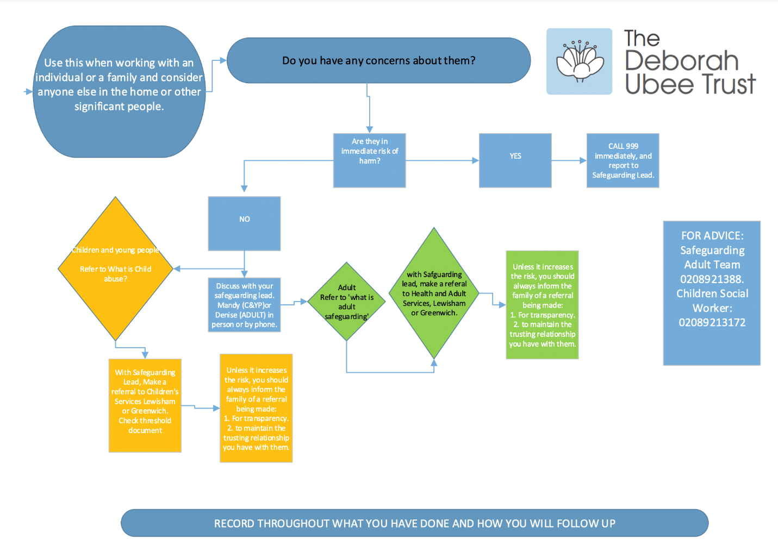
Reporting procedures and staff responsibilities
DUT work on the premise of the 6 R's
Recognise concerns that a child or adult is being harmed or might be at risk of harm.
Respond appropriately to a child or adult who is telling you what is happening to them.
Report/refer the concerns according to DUT’ safeguarding procedures (the Safeguarding Manager, Social Care, or police).
Record the concerns appropriately and any subsequent action taken.
Resolve – take responsibility to ensure that reports and referrals made are followed up in a timely way and take further action if not satisfied with the response.
Reflect on your learnings from the safeguarding process and on how to support the wellbeing of yourself and others involved. Practitioners must include the safeguarding process in their clinical supervision.

There are four key steps to follow to help you to identify and respond appropriately to possible abuse and/or neglect.

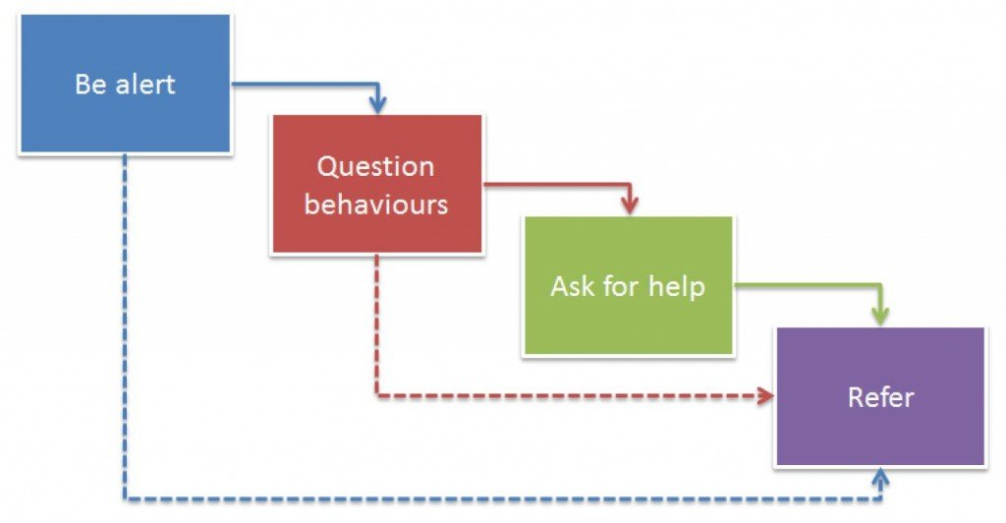

Non-clinical staff and trustees are responsible for:
Ensuring they know and adhere to the safeguarding procedures as outlined in this policy and other related policies and procedures including when working with external partners.
Completing the safeguarding training required for their role.
Raising with the Safeguarding Lead immediately, any safeguarding concerns they identify.

All clinical staff are responsible for:
Ensuring they know and adhere to the safeguarding procedures as outlined in this policy and other related policies and procedures including when working with external partners
Raising any concerns immediately with the DSL and in clinical supervision.
Completing PREVENT training.
Completing training appropriate to their role.

Directors are responsible for:
Supporting and encouraging their teams to follow all appropriate safeguarding procedures.
Providing additional support and advice for a member of staff with any safeguarding concern.
Taking ownership of concerns raised by volunteers, as the DSL.
Abiding by safer recruitment practices.
Ensuring that all new staff and volunteers are fully inducted/trained to the appropriate level in safeguarding practices.
Ensuring staff have access to appropriate safeguarding advice and support.
Checking that safeguarding referrals, incident reports and actions taken are recorded, fully reviewed, and logged in a restricted file.
Providing oversight and supporting DUT to:
ensure young people, adults, and their families are aware of the DUT safeguarding procedures;
appraise the training needs of all teams on a regular basis;
develop guidance and deliver training to increase the level of understanding and expertise on safeguarding across all teams, including safer recruitment training;
ensure that there is a clear and fair system of high-quality supervision for all staff who may benefit from it;
providing an annual report to the Board of Trustees regarding our safeguarding activity;
keeping up to date with relevant law, guidance, and case examples.

Record keeping and reporting Safeguarding concern:
The DSL will record any disclosure or concern in the Safeguarding log, the disclosure or concern will be written in the client's own words and signed and dated by the practitioner involved, as soon as possible after the incident or disclosure is made.
The DSL will record the action taken, including justification for the action.
If an Adult or Child Social Care referral is made this should be documented and outcome logged.
The safeguarding will only be closed after being taken to DUT’s Quarterly Safeguarding meetings with the DTS (Designated Trustee for Safeguarding).

Recruitment and selection
Statement: The TDUT will ensure safer and inclusive recruitment is considered at all levels of the recruitment process and will apply rigorous procedures for the recruitment of those delivering clinical services or who encounter, both directly and indirectly, children, young people, or vulnerable adults. As an absolute minimum, the following standards should be followed:
- All prospective workers (paid and unpaid) should submit a c.v. which asks for details of their previous employment together with a covering letter in which the candidate must show their suitability and understanding of the role. The names of two referees, at least one of whom can vouch for their professional ability, experience and conduct must be given. In the case of a student, one reference must be from the academic tutor. All prospective workers (paid and unpaid) should have an Enhanced DBS (DISCLOSURE AND BARRING SERVICE)
- check before they start employment or volunteering with the DUT. Anyone who refuses to do so will not be employed.
- The interview for any counsellor, therapist or practitioner must consist of at least a two-step process to ascertain suitability through interview, example of play-led practice or role-play.
- All prospective workers (paid and unpaid) should be interviewed to establish previous experience of working in an environment where there is contact with the relevant service user (children, adolescent, adult), and perceptions of acceptable behaviour.
- Nobody will start work before references have been received. Referees will be reminded that references should not misrepresent the candidate or omit saying things that might be relevant to their employment.
- All appointments to work with service users will be subject to an agreed probationary period.
- New members of staff will be clear about their responsibilities, who they are manged by and, wherever possible, work to an agreed job description.
- These guidelines should be available to everyone and fully discussed as part of an induction process.

Induction
With the aim to integrate well all members of the DUT, our induction programme is tailored to the requirements of each service i.e., children and young people, adult, and reception/administration. In common, all induction training will include:
- Contracting this includes explaining probation period and yearly appraisals
- Ensure all new members of staff should be clear about their responsibilities
- Policy and procedures of DUT
- Health and Safety information
- Confidentiality and professional boundaries
- Codes of conduct
- Data protection UK GDPR (General Data Protection Regulation)
- Line Management protocols explained
In addition, induction for clinical staff will include:
- Safe storage of client information/notes. Training on safe note taking.
- Safeguarding TED Tell/Explain/Describe procedure, and reporting procedure (6 R’s) Training.
- Supervision expectations explained.
- Continued Personal Development provisions explained.
- Training on Safety planning procedures
- Risk assessment procedure explained
- Information on accessing the PAPYRUS Debriefing Service.
Non-clinical staff can access counselling support through the DUT’s Mutual Counselling Agreement.

Training
All Staff, volunteers and Trustees are trained in Safeguarding, levels differ according to role:
Reception and Trustee staff Level 1
Practitioners and Volunteers Level 2
Supervisor and DDSL Level 3
Designated Trustee of Safeguarding (DTS) Level 4
DSL Level 5

- All onboarding staff must read and acknowledge understanding of all DUT policies and procedures.
- DUT will record details of all staff and practitioner’s safeguarding certification and level and note renewal dates.
- DUT require practitioners to have PREVENT training.
- Practitioners and Volunteers will receive Continued Personal Development training provided by DUT and have access to training from Greenwich Safeguarding Children partnership.
- All Practitioners and Volunteers will follow and use TED Tell/Explain/Describe only when working with a safeguarding disclosure. This will first be introduced at induction and revisited at annual reviews and included in relevant training.

Good practise
- Practitioners must receive regular supervision, appropriate to the number of clients seen and no less than 1.5 hours per-month, from a qualified supervisor. Additionally, practitioners can access PAPYRUS debriefing service if needed.
- All connected with the DUT must be aware that behaviour in their personal lives, and in places other than those designated as a workplace by the DUT, may impact upon their work with children, young people and their families, vulnerable adults, colleagues, and the reputation of the DUT.
- Under no circumstances should visitors be unaccompanied and left to wander around the centre when clients are present.
- Staff should be alert to strangers frequently waiting outside the centre with no apparent purpose. Children should not be collected by people other than their parent, or guardian, or carer unless notification is received via the service director confirming otherwise.
- Health and safety measures must be adhered to.
- Intimate care can be defined as any care which involves washing, touching, or carrying out a procedure to intimate, personal areas which most people usually carry out themselves, but what some children or vulnerable adults are unable to do because of their age, physical difficulties, or other special need. It would be extremely rare for DUT clients to need assistance with personal care. However, in a case where a child or adult would require assistance with personal care, the parent, guardian, or carer will be instructed to always remain on site to assist them should the need arise. This means that no staff or volunteer should assist with any intimate care task.

Related policies and procedures – The Deborah Ubee Trust:
Recruitment
Guidance on recognising abuse
Whistleblowing
Complaints Procedure
Confidentiality

Date Policy Ratified: 08/08/2022
Date for Policy Review: August 2023

Note: Policies can be ratified at any time if change to Government guidelines, or ineffective in practise.

Appendix 1
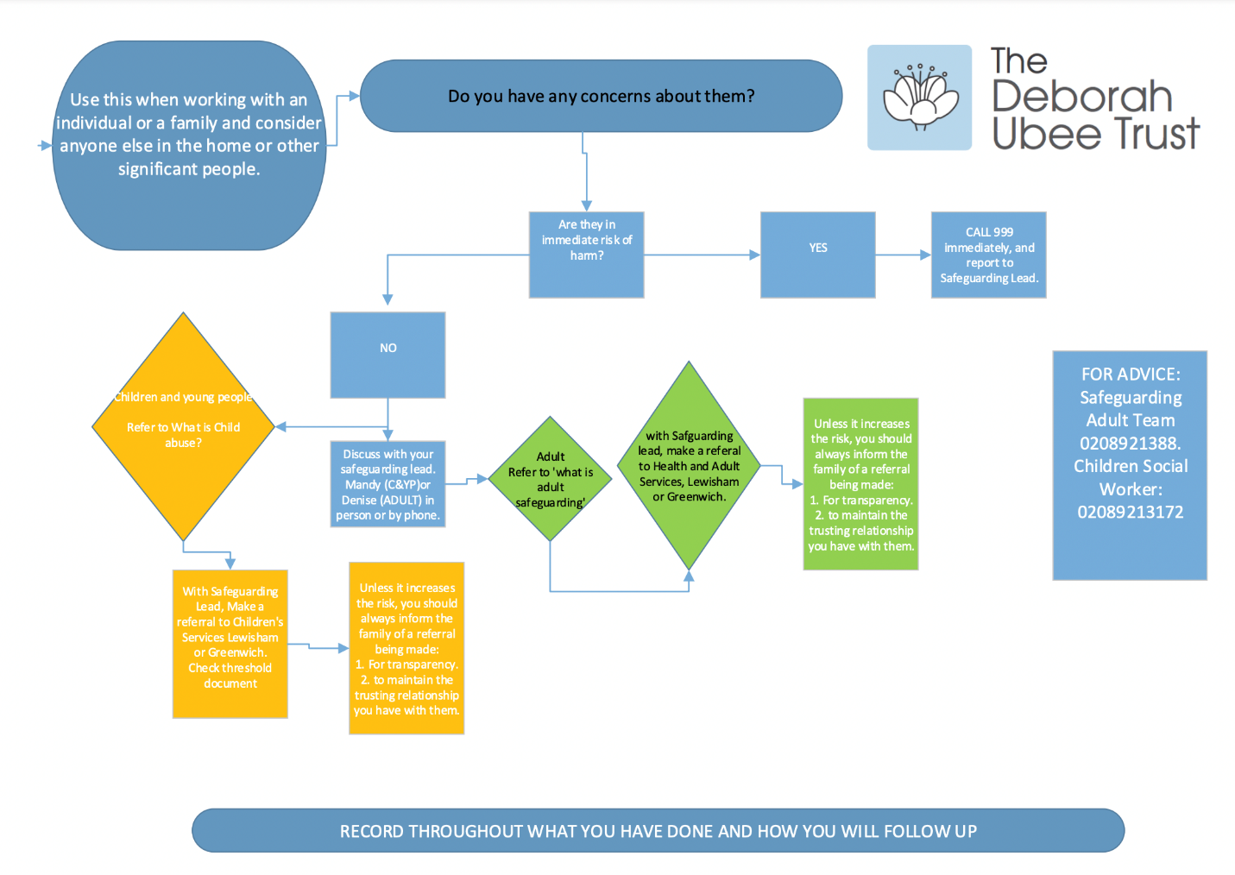
Appendix 2

Please see attached (Additional Adult Safeguarding)

